Saturday, February 9, 2019
P.P.19.11
Also,

Comparing these with

shows that
, ,

Hence,

Since , . Consequently, .

P.P.19.12 This is a series connection of two two-ports.

For , , ,
For , , ,

Thus,

P.P.19.13 We convert the upper T network to a network, as shown below.

j5 S

25 S

-j5 S

,

For ,
, ,

For ,
,

Since and are in parallel,

P.P.19.14 Convert the left network to a T network.
, ,

Putting this network into the given network produces the network shown below. This may be regarded as a cascaded connection of T two-port networks.

N_{a}

N_{b}

20

60

40

10

15

6

For ,
,
,

For ,
,
,

Hence,

We can now use MATLAB to obtain T.

>> Ta=[1.6,30;0.1,2.5]
Ta =
1.6000 30.0000
0.1000 2.5000
>> Tb=[3,220;0.05,4]
Tb =
3.0000 220.0000
0.0500 4.0000
>> T=Ta*Tb
T =
6.3000 472.0000
0.4250 32.0000

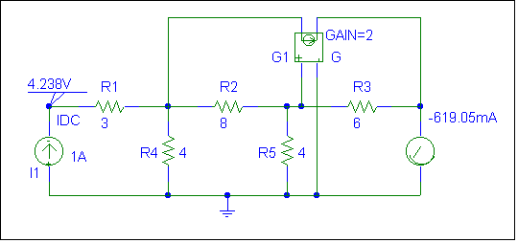
P.P.19.15 To obtain and , simulate the schematic in Fig. (a) using PSpice.

(a)

Insert a 1-A dc current source to account for . Also, include pseudocomponents VIEWPOINT and IPROBE to display and respectively. When the circuit is saved and run, the values of and are displayed on the pseudocomponents as shown in Fig. (a). Thus,
,

To obtain and , insert a 1-V dc voltage source at the output port to account for . The pseudocomponents VIEWPOINT and IPROBE are included to display and respectively. After simulation, the schematic displays the results as shown in Fig. (b).
,
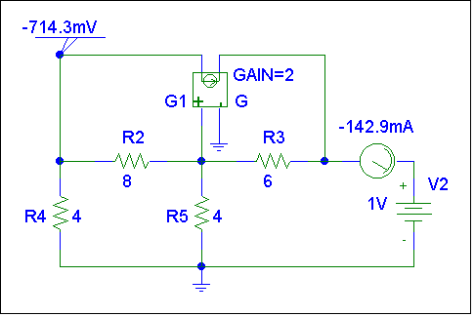

(b)
Thus,

P.P.19.16 Insert a 1-A ac current source at the output terminals to account for . Include two VPRINT1 pseudocomponents to output and . For each VPRINT1, set the attributes to AC = yes, PHASE = yes, and MAG = yes. In the AC Sweep and Noise Analysis dialog box, set Total pt : 1, Start Freq : 60, and End Freq : 60. The schematic is shown in Fig. (a).

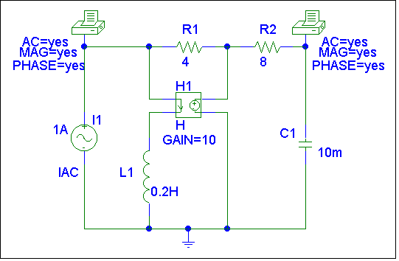

(a)

Once the schematic is saved and run, the output results include :

FREQ | VM($N_0002) | VP($N_0002)
6.000E+01 | 3.987E+00 | 1.755E+02

FREQ | VM($N_0003) | VP($N_0003)
6.000E+01 | 1.752E-02 | -2.651E+00

From this table,
,

Similarly, insert a 1-A ac source at the output port with the two pseudocomponents in place as in Fig. (a). The result is the schematic in Fig. (b).
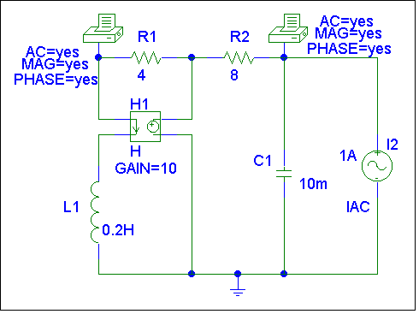

(b)

When the schematic is saved and run, the output results include :

FREQ | VM($N_0002) | VP($N_0002)
6.000E+01 | 1.000E-30 | 0.000E+00

FREQ | VM($N_0003) | VP($N_0003)
6.000E+01 | 2.651E-01 | 9.190E+01

From this table,

Thus,

P.P.19.17 In this case, , .

The gain for the transistor is given as, V_{o} /V_{b} = –123.61

To calculate the gain of the circuit we need to use,

–V_{s} + 150kI_{b} + V_{b} = 0 or 0.002 = 150k(0.002/156k) – V_{c}/123.61

V_{c} = –9.506 mV which leads to the gain = –9.506/2 = –4.753

The input resistance for the transistor is equal to h_{ie} = 6 kΩ.

The input resistance for the circuit is equal to,

156 kΩ

P.P.19.18 Let

Dividing both numerator and denominator by gives

i.e.

As a third order function, we can realize by the LC network shown in Fig. (a).

L₃

1

C₂

(a)

L₁

+

V₁

+

V₂

L₃

C₂

(b)

L₁

y₂₂ = 1 / Z_{A}

Z_{B}

Hence,
L₁ = 1.0 H, C₂ = 500 mF, L₃ = 1.0 H.

